Case1GW.sim

Beginning in November of 1995, a manufacturing company deposited its radioactive and
nonradioactive by-products onto the ground, contaminating in a 10m x 10m area across, by 15m deep volume. The deposit is not covered. The waste represents the only waste unit at the facility. The site is near the Green Stone River. The Site was ordered closed by the U.S. Environmental Protection Agency. Constituents of concern include antimony, strontium 90, and trichloroethylene. While the site was still active, poor management practices resulted in a considerable amount of wind-blown particulate matter being transported from the site. Over the years, the residential soil of the nearby town of Fieldview became contaminated. Residential soil samples have been taken.

Samples have also been taken of the site sediments. The river is used for drinking water, irrigation, and drinking water for livestock, although it is not used for irrigation of animal feed. Also, fishing and swimming occur on this stretch of the river. The local population consumes aquatic life from the river, and locally grown crops and livestock. There is an intake structure 100ft. downstream from where the contaminants enter the river; this structure is used to supply feed/stock water and irrigation water to two nearby agricultural farms: one in Bend County and one in Blue County.

Contaminants have been measured in the local groundwater system. Beneath the site, contaminants move through two vadose zones prior to reaching the water table. Several private and municipal wells use the groundwater from the same aquifer; however, most of the wells are located significantly up gradient from the landfill, are uncontaminated, and do not change the groundwater flow system when pumping. One pumping well though is located down-gradient of the waste site, and is contaminated with low levels of constituents. This well is currently being used as a municipal drinking water well for the town of Fieldview. Besides contaminating the pumping well, the contaminated groundwater also recharges to the Green Stone River.

The area is heavily agricultural and dry deposition of contaminants on plants and consumption by humans is possible. It is also possible for plants to uptake residual chemicals from the soil. All records and information pertaining to the site, including maps, photographs, and sampling result summaries are stored at the County Health Department in Fieldview.

In summary, a contaminated soil site has emissions to the air and leaching to the groundwater through two vadose zones prior to reaching the water table. Contamination reaches a nearby withdrawal well and continues on to contaminate a nearby river. The same people are exposed to withdrawn groundwater and surface water. They are also exposed to the contamination from the air pathway and from direct contact with the contaminated surface soils associated with the site.

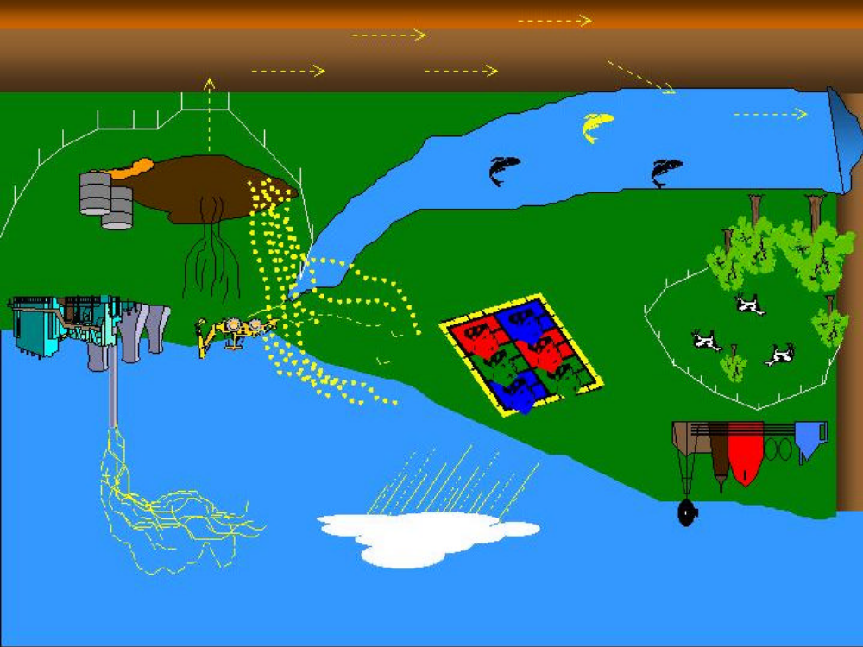

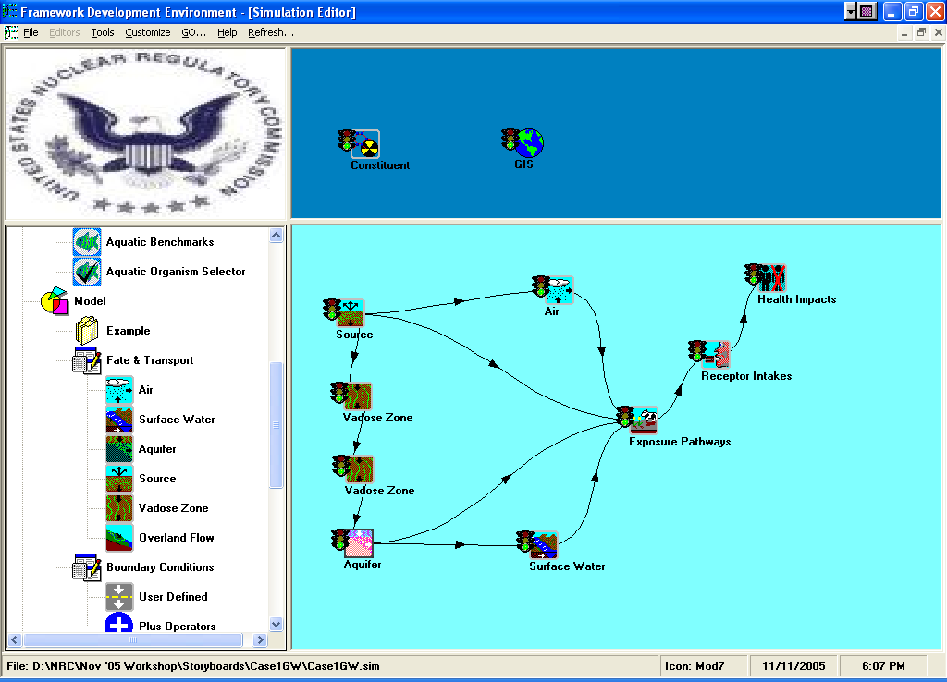
Case 1

Note: When creating and preparing to run a simulation, it is important to complete the General Info sections for each module in the simulation before attempting to input any of the User Inputs. This will require two steps, first completing all of the simulations General Info screens beginning with icons in the Global Workspace, and then completing all of the User Inputs for the simulation beginning with the icons in the Local Workspace.


Constituent

General Info
Label: Constituents
Applicable Module: FRAMES Constituent Database Selection
User Input
Select from All Possible Contaminants:
Antimony
STRONTIUM-90
Trichloroethylene


Source

General Info
Label: Source
Applicable Model: MEPAS 5.0 Source in Soil

Options

Medium type for waste zone - STMEDIA | soil/vadose
Leaching loss route– STINF _ OP | Compute Pathway
Overland runoff loss route– STOVL _ OP | Turn off pathway
Suspension loss route– STSUS _ OP | Compute Pathway
Volatilization loss route– STVOL _ OP | Turn off pathway
Known Source/Sink – STSRC _ OP | Turn off pathway
Time interval for simulation – STDELTA _ T | 1 | years
Time period for simulation – STMAXTIME | 100 | years
Residual mass for simulation - STMINWST | 0.05 | fraction

Waste Zone

Thickness of clean overburden- STCLEAN | 0.0 | m
Thickness– STTHICK | 15.0 | m
Length - STLENGTH | 10.0 | m
Width - STWIDTH | 10.0 | m
Bulk density – STZBULKD | 1.65 | g/cm^3
Total porosity – STTOTPOR | 30 | %
Moisture content – STMOISTC | 15.0 | %
Volumetric air content – STAIRSPC | 0.15 | fraction
Average air temperature - STAVTEMP | 53.006 | F
Height above ground of local wind measure - STWINDHT | 10 | m
Mean annual wind speed – STAVWINDV | 2.0 | m/s

Suspension

Dry bulk density of surface soil - STSBULKD | 1.65 | g/cm^3
Fraction of surface cover - STCORRSC | 0%<=x<=1%
Surface roughness length – STLOCSUR | 1.0 | cm
Surface area covered with vegetation - STVEGFR | 0 | fraction
Surface area covered with a crust layer – STCRUST | 0 | fraction
Number of mechanical disturbances to site | 1 | #/month
Maximum wind speed at site – STMAXWIND | 22 | mi./hr.
Thornwaite’s Precipitation – Evaporation index - STPEI | 25
Aggregate size distribution -- STSDISTB | .33 | mm
Is there roadway travel at the site – STROADS | None
Paved roadway
Distance of roadway traveled – STRTDIST |  | km
Average speed of vehicles per trip – STVSPEED |  | km/hr
Average weight of vehicles – STVWEIGH |  | Ton
Number of round-trips per month – STRTNUM |  | #/day
Percent of silt on road surface - STSILT |  | %
Average number of vehicle wheels - STWHEELS |  | #
Unpaved Roadways
Distance of roadway traveled – STRTDIST |  | Km
Average speed of vehicle per trip -- STVSPEED
Average weight of vehicles – STVWEIGH
Average number of vehicles per day -- STRTNUM
Percent of silt on road surface – STSILT
Dry surface moisture content -- STDRYSCO

Hydrology

Elevation of LCD station – STLCDELEV | 223 | m
Latitude of waste site – STLAT | 47.01 | degrees
Elevation of waste site – STELEV | 223 | m
SCS curve number - STSCSCN | 39
Top soil water capacity – STAVAILW | 1.1 | cm
# of days with >0.254mm precipitation – STNUMPRCP | 68

Monthly Climatology

Param | Temp | Percip | Windsp | Cloudy | Precip days | Min humid | Max humid
Unit | F | In | Mi/hr | Fraction | days | % | %
 | sttemp | stmprecip | stwindv | stcloud | stmnumpre | strhmin | strhmax
January | 30.002 | 1.0 | 0 | 0.79 | 9 | 65 | 82
February | 37.9994 | 1.0 | 0 | 0.76 | 7 | 58 | 80
March | 44.0006 | 1.5 | 0 | 0.68 | 6 | 40 | 70
April | 51.9998 | 1.5 | 0 | 0.64 | 5 | 32 | 70
May | 60.9998 | 1.25 | 0 | 0.59 | 5 | 30 | 70
June | 69.0008 | 1.1 | 0 | 0.53 | 5 | 25 | 70
July | 77.0 | 1.0 | 0 | 0.29 | 2 | 20 | 70
August | 75.0002 | 0.9 | 0 | 0.34 | 3 | 20 | 75
September | 66.0002 | 0.8 | 0 | 0.41 | 3 | 25 | 80
October | 53.0006 | 0.9 | 0 | 0.58 | 5 | 25 | 80
November | 39.9992 | 0.9 | 0 | 0.77 | 8 | 30 | 85
December | 33.0008 | 1.0 | 0 | 0.81 | 10 | 30 | 85

K_{d}’s
Equilibrium coefficient KD– STKD |  | ML/g
Antimony | 2 | 0.0 | 0
 |  | 0.0 | 100
STRONYIUM-90 | 2 | 2.4 | 0
 |  | 2.4 | 100
Trichloroethylene | 2 | 0.76 | 0
 |  | 0.76 | 100
*YTTRIUM | 2 | 10 | 0
 |  | 10 | 100

Constituent Properties
Water solubility-STSOL
Antimony |  | 1.0E+06 | mg/L
STRONTIUM -90 |  | 1.0E+06 | mg/L
Trichloroethylene |  | 1100.0 | mg/L
*YTTRIUM -90 |  | 1.0E+06 | mg/L
Contaminant inventory quantity-STINVEN
Antimony | Worksheet | 1000 | kg
STRONTIUM-90 | Worksheet | 1.0 | Ci
Trichloroethylene | Worksheet | 1000.0 | g
*YTTRIUM-90 | Worksheet | 1E-30 | Ci
Decay/degradation half life-STGHALF
Antimony |  | 1E+20 | day
STRONTIUM -90 |  | 10600.0 | day
Trichloroethylene |  | 1E+20 | day
*YTTRIUM -90 |  | 2.7 | day
Fraction of volatilization release-STVOLRAT
Antimony |  | 0.0 | Fraction
STRONTIUM-90 |  | 0.0 | Fraction
Trichloroethylene |  | 0.0 | Fraction
*YTTRIUM-90 |  | 0.0 | Fraction

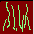
Vadose Zone Transport

General Info
Label: Vadose 1
Applicable Model: MEPAS 5.0 Vadose Zone Module

Composition (Soil)

Soil Class – WP-CLASS | Sand
Percentage of sand – WP-SAND | 92.0 | %
Percentage of silt – WP-SILT | 5.0 | %
Percentage of clay – WP-CLAY | 3.0 | %
Percentage of organic matter – WP-OMC | 0.0 | %
Percentage of iron and aluminum – WP-IRON | 0.0 | %
Soil type coefficient – WP-SOILCOEF | 4.05

Characteristics

pH of the pore water – WP-PH | 7.0 | pH
Total porosity – WP-TOTPOR | 36.0 | %
Field capacity – WP-FIELDC | 9.0 | %
Hydraulic conductivity – WP-CONDUC | 570.24 | cm/day
Thickness of this layer – WP-THICK | 212.3 | cm
Longitudinal dispersivity – WP-LDISP | 0.07 | ft
Dry bulk density – WP-BULKD | 1.67 | g/cm^3

Constituent Properties

Adsorption coefficient – WA-SUBKD
Antimony | 2 | mL/g
STRONTIUM-90 | 24.3 | mL/g
*YTTRIUM-90 | 10 | mL/g
Trichloroethylene | 0.107 | mL/g
Water Solubility – WP-SOL
Antimony | 1E + 20 | mg/L
STRONTIUM-90 | 1E + 20 | pCi/mL
*YTTRIUM-90 | 1E + 20 | pCi/mL
Trichloroethylene | 1100 | mg/L
Half-life in ground water – WP-GHALF
Antimony | 1E+20 | day
STRONTIUM-90 | 10600 | day
*YTTRIUM-90 | 2.7 | day
Trichloroethylene | 1E+20 | day

Vadose Zone Transport

General Info
Label: Vadose 2
Applicable Model: MEPAS 5.0 Vadose Zone Module

Composition (Soil)

Soil Class – WP-CLASS | Sand
Percentage of sand – WP-SAND | 91.2 | %
Percentage of silt – WP-SILT | 6.3 | %
Percentage of clay – WP-CLAY | 2.5 | %
Percentage of organic matter – WP-OMC | 0.0 | %
Percentage of iron and aluminum – WP-IRON | 0.0 | %
Soil type coefficient – WP-SOILCOEF | 4.0

Characteristics

Ph of the pore water – WP-PH | 8.5 | pH
Total porosity – WP-TOTPOR | 38.0 | %
Field capacity – WP-FIELDC | 9.0 | %
Hydraulic conductivity – WP-CONDUC | 570.24 | cm/day
Thickness of this layer – WP-THICK | 15.2 | Cm
Longitudinal dispersivity – WP-LDISP | 0.0 | Cm
Dry bulk density – WP-BULKD | 1.64 | g/cm^3
Constituent Properties

Adsorption coefficient – WA-SUBKD
Antimony | 2 | mL/g
STRONTIUM-90 | 2.4 | mL/g
*YTTRIUM-90 | 10 | mL/g
Trichloroethylene | 0.1 | mL/g
Water Solubility – WP-SOL
Antimony | 1E + 20 | mg/L
STRONTIUM-90 | 1E + 20 | pCi/mL
*YTTRIUM-90 | 1E + 20 | pCi/mL
Trichloroethylene | 1100 | mg/L
Half-life in ground water – WP-GHALF
Antimony | 1E + 20 | day
STRONTIUM-90 | 10600 | day
*YTTRIUM-90 | 2.7 | day
Trichloroethylene | 1E + 20 | day

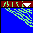
Aquifer

General Info
Label: Aquifer
Applicable Model: MEPAS 5.0 Aquifer Module

Composition

Soil Class – WZ-CLASS | Loam
Percentage of sand – WZ-SAND | 65.0 | %
Percentage of silt – WZ-SILT | 25.0 | %
Percentage of clay – WZ-CLAY | 10.0 | %
Percentage of organic matter – WZ-OMC | 0.0 | %
Percentage of iron and aluminum – WZ-IRON | 0.0 | %

Characteristics

Percentage constituent flux entering aquifer –  WZ-FRACT | 100.0 | %
pH of the pore water – WZ-PH | 7.0 | pH
Total porosity – WZ-TOTPOR | 46 | %
Effective porosity – WZ-EFFPOR | 20.0 | %
Darcy velocity – WZ-PVELOC | 0.017 | ft/day
Thickness of aquifer – WZ-THICK | 40.0 | ft
Dry bulk density – WZ-BULKD | 1.43 | g/cm^3

Concentration Locations

Usage location Ground water_Well (fcm5)
Longitudinal distance to well – WZ-DIST | 10000 | cm
Perpendicular distance from plume center line to well– WZ-YDIST | 0.0 | cm
Vertical distance below water table to well– WZ-AQDEPTH | 20 | cm
Longitudinal dispersivity – WZ-LDISP | 1000 | cm
Tranverse dispersivity – WZ-TDISP | 330 | cm
Vertical dispersivity – WZ-VDISP | 2.5 | cm

Flux Locations

Usage location Surface_Water (riv10)
Longitudinal Distance to flux location– WZ-DIST | 100.0 | m
Longitudinal dispersivity – WZ-LDISP | 10.0 | m
Tranverse dispersivity – WZ-TDISP | 3.3 | m
Vertical dispersivity – WZ-VDISP | 0.025 | m

Constituent Properties

Antimony | 0 | mL/g
STRONTIUM-90 | 2.4 | mL/g
*YTTRIUM-90 | 10 | mL/g
Trichloroethylene | 0.382 | mL/g
Water Solubility – WZ-SOL
Antimony | 1E + 20 | mg/L
STRONTIUM-90 | 1E + 20 | pCi/mL
*YTTRIUM-90 | 1E + 20 | pCi/mL
Trichloroethylene | 1100 | mg/L
Half-life in ground water – WZ-GHALF
Antimony | 1E + 20 | day
STRONTIUM-90 | 10600 | day
*YTTRIUM-90 | 2.7 | day
Trichloroethylene | 1E + 20 | day

Air


General Info
Label: Air
Applicable Model: MEPAS 5.0 Air Module

Climatology

Reference weather station (AC-LCDREF) | Hanford Met Station
Morning mixing height (AC-MIXAM) | 400.0 | m
Afternoon mixing height (AC-MIXPM) | 1400.0 | m
Annual precipitation (AC-RAIN) | 6.3 | in.
Precipitation days per year (AC-PRENUM) | 68
Thunderstorms per year (AC-NUMTS) | 10

Topographical Data

Complex Terrain, use wind channel modeling (AR-CHANL)
Elevated release, use regional topographical data (AR-TOPTYP)
Elevation of release unit (AR-TOPBAS)

Surface Roughness

Regional surface roughness (AR-REGSUR) = all 10 cm

Joint Frequency Data /General

Data Station (AJ-STATNM) | Hanford Met Station
Anemometer height (AJ-ANEMHT) | 15.2 | m
Average roughness length (AJ-RLEN) | 45.5 | cm
Wind Speed midpoints (AJ-WINDS) | 0.671 | m/s
 | 2.46 | m/s
 | 4.48 | m/s
 | 6.94 | m/s
 | 9.62 | m/s
 | 12.53 | m/s
Wind joint frequency Calms (AJ-CALMS) A | 0.000 | Number
B | 0.000 | Number
C | 0.000 | Number
D | 0.000 | Number
E | 0.000 | Number
F | 0.000 | Number
G | 0.000 | Number

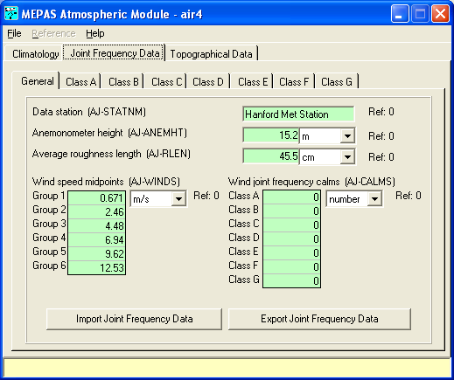
Class A

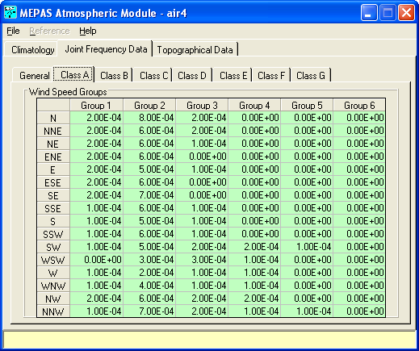

Classes B, C, D, E, F, and G

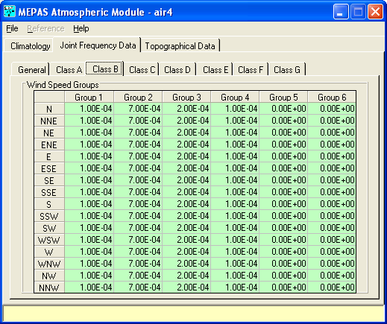

Surface Water

General Info
Label: Surface Water
Applicable Module: MEPAS 5.0 River Module

Flow Velocity at contaminant entry point– WW-VELOC | 3 | ft/s
Depth at contaminant entry point – WW-DEPTH | 10.0 | ft
Width at contaminant entry point – WW-WIDTH | 100.0 | ft
Usage Location | Ground Water Well (fcm5)
Distance from source to location – WW-DIST | 100.0 | ft
Average annual discharge at location – WW-DISCHG | 3000 | ft^3/s


Exposure Pathways

General Info
Label: Groundwater Well
Applicable Model: MEPAS 5.0 Exposure Pathways Module
Scheme: 8

Exposure Controls

Time to start exposure computation – EC-TEXPOS | 0.0 | Yr.
Maximum time for reporting – EC-MAXTIM | 100.0 | Yr.
Number of time points for evaluation – EC-NTIMES | 50

Leach Rates

Leach rate selection option – EC-LEACHOPTION | User provided leach rate constants
Parent surface soil leach rate constant
Antimony | 1.0 | 1/yr.
STRONTIUM-90 | 1.0 | 1/yr
Trichloroethylene | 1.0 | 1/yr
Progeny surface soil leach rate constant
YTTRIUM-90 | 1.0 | 1/yr.

Air

Exposure duration-EA-ATED | 30.0 yr

Pathways:
Plant Product Ingestion   Leafy vegetables   Other vegetables  Animal Product Ingestion   Meat   Milk | Other Pathways   Soil-Ingestion   Soil-Inhalation   Soil-Dermal   Soil- External   Air- External   Air-Inhalation

Deposition:
Thickness of soil receiving deposition – EA-TAS | 0.04 | m
Density of soil receiving deposition – EA-RHOAS | 1.5 | g/cm^3

Ground Water

Exposure duration – EG-DGWED | 30.0 | yr.

Pathways:
Plant Product Ingestion   Leafy vegetables   Other vegetables  Animal Product Ingestion   Meat   Milk | Other Ingestion   Drinking water   Shower water  Inhalation   Air-Volatiles from water  ○ Shower-Air   Indoor-Air | Dermal   Shower

Water Usage:
 Animal Drinking
◻ Irrigation of animal feed
Fraction of the year that surface water is used for irrigation –EG-FIRR | 1.0
Irrigation rate - EG-CIRR | 100.0 | L/m^2/m
Domestic water distribution time – EG-TWTR | 0.5 | day
◻ Domestic water is treated – EG-LTRTL

Soil

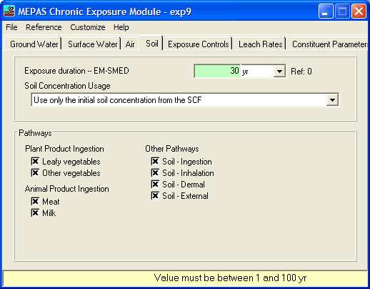

Surface Water

Exposure duration – EW-DSWED | 30.0 | yr.

Pathways:
Plant Product Ingestion   Leafy vegetables   Other vegetables  Animal Product Ingestion   Meat   Milk   Finned Fish   Shell Fish | Other Ingestion   Drinking water   Shower water   Swimming water   Shoreline sediment  Inhalation   Air-Volatiles from water   Shower-Air  ○ Indoor-Air | Dermal   Shower   Swimming   Shoreline  External   Swimming   Shoreline   Boating

Water Usage:
 Animal Drinking
◻ Irrigation of animal feed
Fraction of the year that surface water is used for irrigation –EW-FIRR | 1.0
Irrigation rate - EW-CIRR | 100.0 | L/m^2/m
Domestic water distribution time – EW-TWTR | 0.5 | day
◻ Domestic water is treated – EW-LTRTL
Recreational:
Finfish ingestion harvest delay time-EW-TFISH | 10.0 | day
Shellfish ingestion harvest delay time-EW-TINV | 10.0 | day
Thickness of shoreline sediments-EW-TSS | 0.04 | m
Density of shoreline sediments-EW-RHOSS | 1.5 | g/cm^3
Finfish fillet correction factor-EW-TISSUE | 1

Constituent Parameters
Physical loss half-time in surface soil-EC-SPHALF
Antimony | 1E+20 | day
STRONTIUM -90 | 10600.0 | day
Trichloroethylene | 1E+20 | day
*YTTRIUM -90 | 2.7 | day
Physical loss half-time in groundwater-EC-GPHALF
Antimony | 1E+20 | day
STRONTIUM -90 | 10600.0 | day
Trichloroethylene | 1E+20 | day
*YTTRIUM -90 | 2.7 | day
Physical loss half-time in air-EC-TPHALF
Antimony | 1E+20 | day
STRONTIUM -90 | 10600.0 | day
Trichloroethylene | 1E+20 | day
*YTTRIUM -90 | 2.7 | day
Physical loss half-time in surface water-EC-WPHALF
Antimony | 1E+20 | day
STRONTIUM -90 | 10600.0 | day
Trichloroethylene | 1E+20 | day
*YTTRIUM -90 | 2.7 | day


Receptor Intakes

General Info
Label Receptor Intake
Applicable Models: MEPAS 5.0 Receptor Intakes Module

Body weight of individual –IC-BODYWT | 70.0 | kg.
Exposure duration - IC-EXPDUR | 30 | yr.
Water dermal absorption model-IC-DERM |  | EPA Model
Ground water ingestion rate – IG-UDWGW | 1.4 |  | L/d
Surface water ingestion rate – IW-UDWSW | 1.4 |  | L/d
Age of receptor at start of exposure – IC-TAGE1 | 0.0 |  | yr.
Age of receptor at end of exposure – IC-TAGE2 | 70.0 |  | yr.



Health Impacts

General Info
Label: Health Impacts
Applicable Model: MEPAS 5.0 Health Impacts Module

Chemical
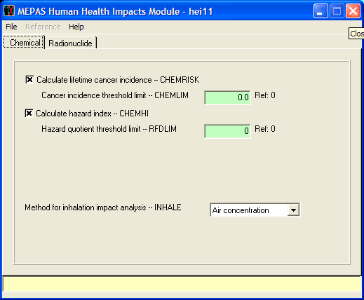

Radionuclide

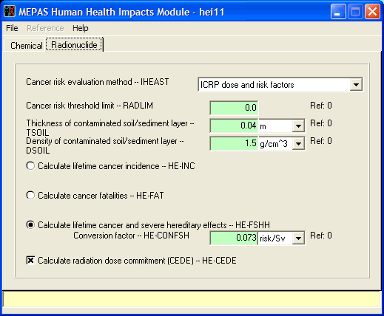

Credit and Revision History:

Case1GW.GID was originally created for use with FRAMES Version 1.x by Gene Whelan. This document (Case1GW.SIM) represents the conversion of the Case1GW test case for use in FRAMES Version 2.0 and was last reviewed and verified by Gene Whelan and Richard Leigh on February 3, 2006.

